**BST 203 – Christian Worldview**

**Introduction**

Every rational being has a worldview. This is because all human beings have ideas, principles, thoughts and convictions or set of beliefs that precede or give birth to values, actions or issues of life. The way we view the world has great impact on us especially on the way we think and interpret events in every given context or environment determines what we do and how we live. What is the worldview?

**The Significance of the Study**

1. To prepare students to understand and adjust to the mindset in order to accommodate our neighbors of different faiths.

2. To adapt to other people’s way of thinking for the purpose of pointing them to Christ.

3. To take the risks and pains in order to respond to some uncomfortable questions like, how do people of other faiths think or perceive reality? What do they value? How do we accommodate other people’s faiths beliefs, philosophies, and presuppositions without abandoning or compromising our Christian faith? What is negotiable and what is not? How do we speak to the post-modern minds so that they would understand our truth of the gospel of Christ?

4. It enables you to explain how Africans think and perceive history, its purpose, God, and creation.

5. It assists students discover that some worldviews repel Christian worldview, some worldview crown Christian worldviews, some worldviews flank Christian worldview, some world views yield to scrutiny by Christian worldview.

**Definition:** What is world view and culture?

From my perspective, world view and culture are systems that attempt to describe people and religion in a given region or continent in terms of particular ideas, belief, norms, customs , values and characteristics.

The Concept worldview” came from the German word “Weltanschauung” and was first created by a German idealist- Immanuel Kant.

A worldview is one’s outlook, and philosophy of life that might be consciously held, but is not.

This definition was scholarly conceptualized by David Noebel as “an ideology, philosophy, theology, movement, and religion that provides a framework to understanding God, the world, man and their relationships. “Furthermore, another scholar, Ekaete Eltang (Mrs) defines “Worldview as lens we use to perceive or look at life, its meaning, reality, purpose, world events and even history.” Prof. Turaki defines worldview as,” a people’s total way of seeing, of understanding, of interpreting, and of constructing the reality of existence (life) out of their historically transmitted and ordered systems of meanings, of symbols and of conceptions of [God, Man] nature, of self, of society.[ and their relation].”[1] B.J. Van Der Walt, says “A worldview is an integrated, interpretive set of confessional perspective on reality which underlines human activity, shape it, motivates it and gives it direction and meaning so that man calling in the world is [not only] spelled out (but also carried out).”[2]

Ronald H. Nash defines that, “A worldview is a conceptual scheme by which we consciously or unconsciously place or fit everything we believe and by which we interpret and judge reality.”[3] The above definition shows us how worldview function/operate as a guide to “a person’s way of life.” Wolters, defined worldview as “the comprehensive mental framework of one’s basic beliefs about things.” Here, “things” in question refer to anything about which it is possible to have belief. It includes human life in general, the meaning of suffering, social morality, the importance of the family, and even God.

*What is culture?* Culture is a combination of the symbolic- expletive dimension of life with the transmissible products, customs, beliefs, values, and norms of a given people in a particular environment. What is the relationship of religion and culture? Religion is the most basic faith function we have and share, because of or nature as God’s image bearers whether recognize or not. Religion thus, informs culture (sometimes directly) through rituals practices (sometime indirectly) by some architectural style.

**THE NATURE OF WORLDVIEW**

The nature in the context of worldview simply refers to the characteristics of worldview. They are as follow:

1. Worldview encompasses the whole of man’s life in that it is sometimes called **cosmoscopes** or **cosmoptic** that is the study of worldview that concerns a view of creation, and man’s action in the world

2. Worldview is also **ontoscope** or **ontoptic** in that it embraces a study of a supreme being (absolute) or a god that gives rise to normality.

3. It is a **mode** and image of looking or seeing the world. As a **mode** it is a perspective, at the world. Its primary concern is not only what is seen but with the results of the viewing. And as an **image** it is perceive as lens, spectacles or glasses with different color of tints, or the window through which we view reality

4. It **guides and orients** us in understanding of the world, and **directing** our life in it, in that, it serves like a **road map** which helps us determine where we find ourselves and how we should determine our route through life. However, worldview doesn’t create the world or the reality.

5 It is not a random collection of ideas, beliefs, values, customs etc., but a **framework (interpretive) or a system of convictions** which cohere in an orderly fashion in a pattern that reveals **interdependence, consistency**, and **unity**.

6. It is both **descriptive and perspective** - in that it is both a **vision of transformation** and blue print for life in the world. It does not only describe or tell you what the world was (what you heard, meant, saw, or imagined), but also prescribes or t ells how the world is or means or should be (what you should see, think, do and means). The nature implies that worldview has both a **facts** and **norms** that provide the standards for which a distinction is drawn between **good and evil, right and wrong, ugly and beautiful, order and disorder; and stresses men’s calling and responsibility in the world.**

7. It requires a full **commitment and humanistic** (fallible). As **full commitment** or surrender means a person’s or group’s commitment that adds value or substance in a concrete way of life to that worldview. It is **humanistic** in that it is typically human, because people live instinctively and maintain an intuitive framework of reference or frame of mind. **But the Christian worldview is not only conventional, revelatory, infallible and divine in origin with a glorious eternity as its ultimate goal.**

**FUNCTIONS OF THE WORLDVIEW**

Van Der Walt in pages17-18 highlights 8 functions as follows:

1. It provides interpretive keys to our understanding of reality and man himself.

2. It integrates (makes a unity of ideas, beliefs, etc) and structures human experience by giving meaning to human existence.

3. It acts as a normative framework in that it enables man to make choice based on the principles and to act accordingly to a specific pattern

4. It acts as an active conviction in the sense that it persuaded and motivate man to proactive towards and awareness of his calling (vocation) and responsibility in order to make a better destiny

5. It functions in the formation of a personal identity and integrity. E.g.; Martin Luther (reformer) said, “Here I stand. I can do no other. No compromise.”

6. It releases not only deep emotion in people, but also offers great stability; because, it supplies a sense of belonging, satisfaction, inner peace and joy.

7. It is usually embodied in symbols which have a motivating, inspiring, and cohesive force for a specific group or community

8. It has diagnostic value in the sense that it distinguishes a friend from enemy; especially in threatening situations the enemy plays an important role.

**Two Views of Interpreting Worldviews of History and Reality**

The diagrams below illustrate the way worldviews are conceptualized and interpreted by both Christians and non-Christians. The first diagram illustrates the non-Christian’s interpretation of life, existence, and history; while the second illustrates the Christian perspective of life, existence, and history.

1. *Cyclical View of History and Existence*

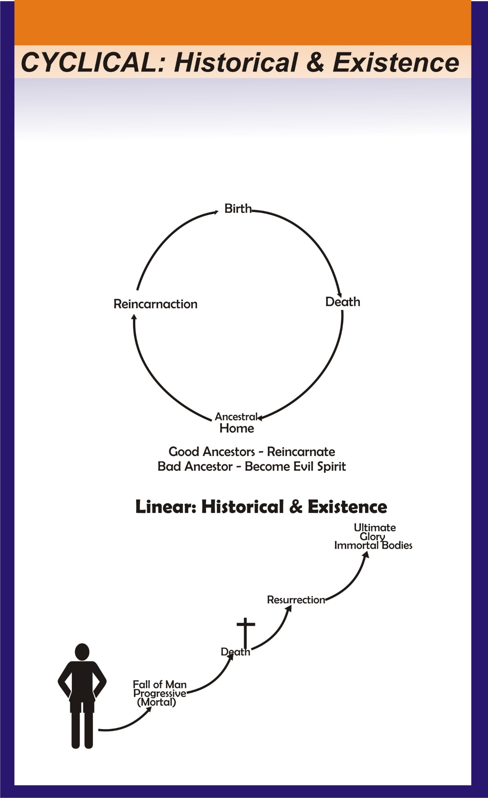

The cyclical interpretation of history is found popular in China, India, the Middle East, Africa, and the ancient Greco-Roman world. It believes that nothing is new under the sun. Everything has been seen before and will be seen again. There is no purpose in history or in any individual’s actions within history. One’s life has no real meaning. One’s goal is to escape the continuous rounds of the cycle of history and existence, to escape reincarnation and one’s karma/ ancestor. In the African and Chinese understanding of these cycles, it is linked to spirits world and dynasties or civilizations respectively. Records were kept of the rise, extent of power, and collapse of dynasties. This history was based on the assumptions that similar behavior led to similar consequences and that patterns of behavior did recur. Confucius taught that a ruler’s misgovernment would result in the withdrawal of the mandate of heaven. History provides lessons for us to learn from so that we know what to avoid and what to follow.[4]

Although the Christian would agree that in one sense there is nothing new under the sun, that the perplexities and problems we experience today have been found in previous generations for millennia, but we cannot agree that the events of history and existence are meaningless. God has his purpose in allowing all that happens for his glory. It is because our problems today are the same as in previous times is why the Bible remains as relevant today as it ever was.

1. *Linear View of History and Reality*

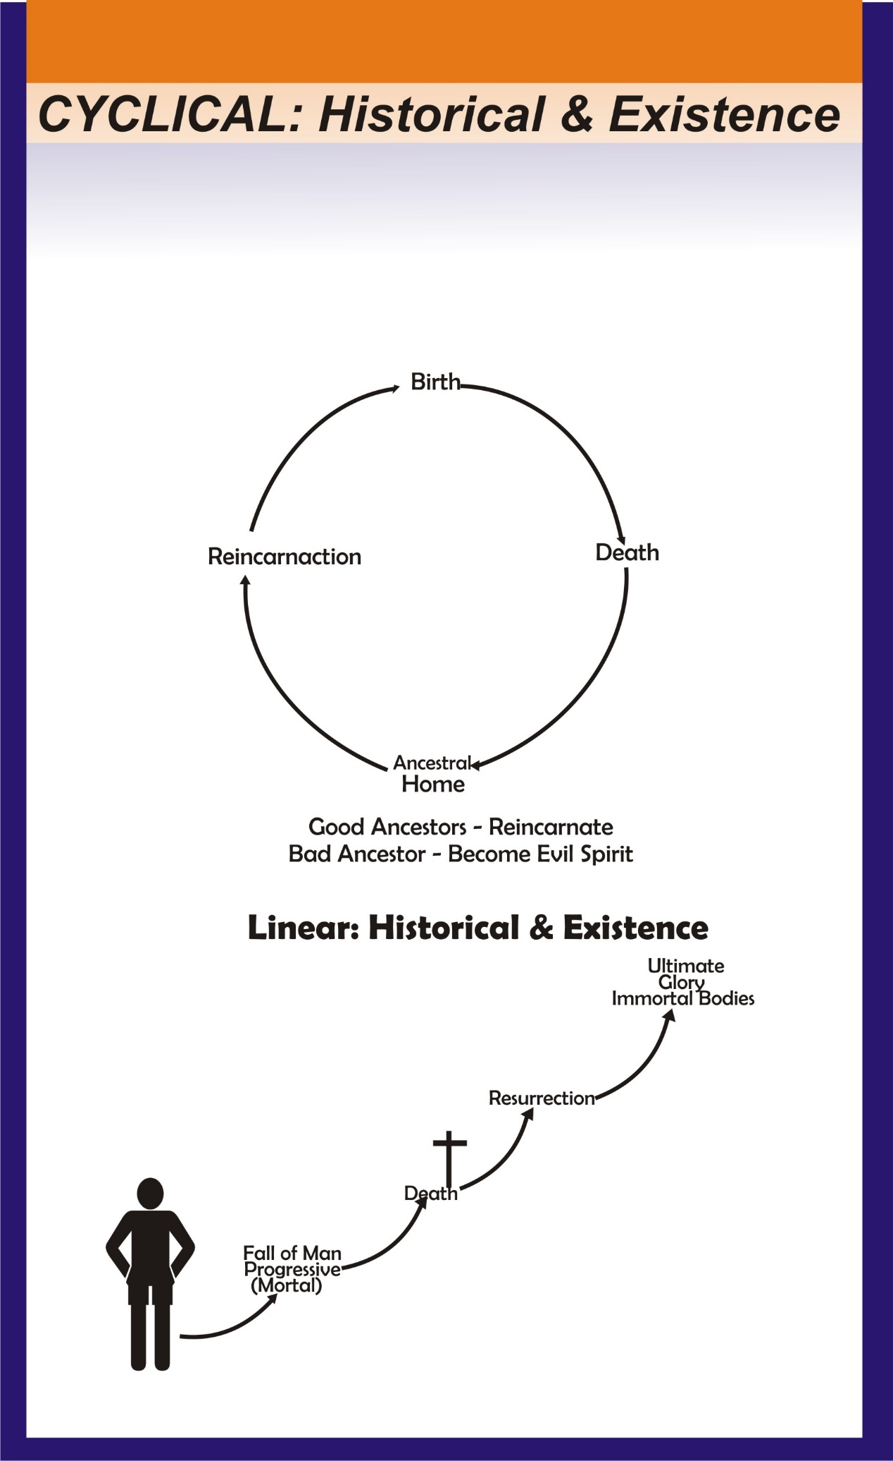

History is working out of God’s purposes. History is going somewhere towards a known glorious end. Though there is much which seems chaotic, it is all nonetheless part of a meaningful sequence that has a beginning, middle, and end. Although our daily news says nothing about God working in daily events, the Bible clearly states that God is the first cause of all that comes to pass. God is active always and everywhere. He is the author, the director, and the main character. The majority of actors fail to notice, but that does not change a thing. In speaking to the Greeks in Athens, the Apostle Paul said:

From one man he made every nation of men that they should inhabit the whole earth; and he determined the times set for them and the exact places where they should live.... For he has set a day when he will judge the world with justice by the man he has appointed. (Acts 17:26, 31)

Notice that God is in control of everything—how long we live, where we live, and when the end of this age will be here. At the appointed day Jesus will come again as our judge or Savior.

History is linear. It had a beginning and is progressing toward an ultimate end. History is the record of the involvement and concern of God in human events. He is revealing himself here and now, there and then. Its end is the new heavens and the new earth and its ultimate goal is the glory of God. As God prophesied through Habakkuk saying, “For the earth will be filled with the knowledge of the glory of the LORD, as the waters cover the sea” (Habakkuk 2:14).

It is only with this worldview that one’s actions have real significance. They are significant both in the area of culture formation in that we recognize continuity between this world and the next, and also in that every act and every decision is an opportunity to display the glory of God in your life—to please him, to manifest his nature and to make him known.[5] It is God through Christ who makes reality, human history, and each event meaningful.

A significant aspect of a Christian view of history is that human beings are seen as makers of history. People are the center of God’s creation and have been entrusted to be culture-creators by the daily task of overseeing and unfolding the creation. This is part of what it means for man to have been made in the image of God.[6]

**Categories of Worldview: There are two types of worldviews**

There are two types of worldviews, namely, the Christian worldview and non-Christian worldview. Their similarities and differences are as follows:

*Christian Worldview*: Is covenantal in that it presupposes God or triune God first and foremost point of contact through revelation in his relation to creation (distinct but not separate from God’s being), the fall of man (rejection of dependence on God) and Redemption (recreation or restoration that is beyond restoration to a new heavens and the new earth. There is no test higher than God by which to prove God. The Christian worldview is not a vicious worldview in that it invites the non-Christian worldview to explore the basic doctrine of God’s sovereignty, man’s free will and exploration of creation. On the other hand, *non-Christian worldviews* are narrow and vicious because they deny the God the creator whom we can explain reality or the world intelligibly (no God no intelligent explanation or interpretation of reality). Further the non-Christian worldview perceives and ascribes all authority to man or nature as its ultimate criterion understanding reality; while the Christian worldview attributes all authority to God and his Word as the ultimate criterion for understanding, interpreting, explaining and evaluating reality.

**Major Elements of Worldview**

1. *God*
2. The worldviews differ greatly on who is God; and some ask “does God exists? If yes, what is the nature of God? Is there only one true God? Is God both a relational and personal (transcendent and immanent) that we can know, love, and act or is God an impersonal being? (Transcendent). Below are some non-Christian worldview about God. Examples of this kind of worldview (i.e. different perceptions of God) are as follows:
3. *Atheists* - deny the existence of God or anything supernatural.
4. *Agnostics*- nothing beyond rational existence and phenomena (physical world) can be known.
5. *Polytheists*- Belief in many Gods there is no one personal God but many gods. They have gods of fire, agriculture, water, rain, trees, rivers.e.tc (Acts 19:23).
6. *Deists*- Stress that God is an impersonal being who created the universe with natural power and laws but left it to run its cause because of his nature- express the transcendence of God.
7. *Pantheists*- God is everything and in everything. Explanation: everyone/ thing is God in its own right. They stress the immanence of God. And they perceive God as a concept that describes how all the natural forces inhabit the universe.

**What is an African worldview of God**? African stories or myths about creation and the fall of mankind teach that God created man good and intended him to have fellowship with God. God lived in the clouds just above mankind, but as mankind went about such daily activities as women pounding cereals /corn or men shooting arrows up in the air, God in his dwelling place in the clouds felt disturbed and decided to move higher in the sky and be far away from mankind. A peculiar myth is told that God’s abode was so close to earth that people could freely travel back and forth between earth and heaven without any restrictions. So one day, a man got drunk and in his stupidity disrespected God. He insulted God to the extent of rubbing his dirty hands on the sky, which was regarded as the face of God. Now God felt embarrassed and took offense with people, and in great anger, he resolved to withdraw and so relocated his abode far from human reach. He hence caused the big chasm which now divides heaven and earth, and thus human access to God has to be bridged by offering traditional sacrifices to God through their tribal gods.

The introduction of Christianity and other monotheistic religions, such as Islam, Judaism and Christianity have added what it is called **henotheism** to the African worldview, that is, the worship of one god without denying the existence of other gods. The priests of African traditional beliefs assume that an African can accommodate the worship of the Christian God along with other gods without creating any serious theological crisis for the believer. The God who is above the lesser gods seems “not to be intimately involved or concerned with man’s world,” rather, “men seek out the lesser powers to meet their desires” (Steyne 1989:35). This leads people to turn to impersonal powers, divinities, ancestors, and spirit beings for help. God is only occasionally mentioned, remembered, or approached.

**Biblical View of God as Covenantal - Condescending God**

God is the God of covenant in that the covenant of redemption (*pactum salutis*) made in eternity past among the members of the trinity or covenant of condescension; creation is covenantally conditioned, thus, Creation exists because of the covenant of works made between God and Adam in the state of original innocence; and the covenant of grace made between God and the elect in Christ. Hence, the covenant of condescension bridges the ontological distance between God and the creature. In this context, it is God’s voluntary condescension that enables us to know the world, to know ourselves, and to know God. God lisps to his creation (Gen 1-2). While remaining God, he stoops down and reveals himself. When does God do this? Answer: Right from the very beginning. As soon as God speaks, that is condescension. When God walks in the garden he condescends, coming down as a theophany, condescending to our level. Does he cease to be God? No. He cannot cease to be God (WCF 7:1). Therefore, Christians believe on the **transcendence** and **immanence** of God because there is an analogical relationship between God and people, since people are created in God’s image; and God is personal and relational being yet distinct from his creation. Unlike Muslims who believe in the rigorous absolute transcendence of God.

1. Yusufu Turaki *Christian Worldview Foundations*, (1993a):86. See also Yusufu Turaki, *Christianity and African Gods: A method in Theology*, Enugu, Nigeria: IBS Press, (1999),5.
2. 2B.J. Van Der Walt, *Window on the World, The Nature of worldview and the Value of a Christian worldview for Africa*. A presentation at Nairobi World Conference of Philosophy, Nairobi, Kenya: 21-25 of July 1991.

  
3. 3Ronald H. Nash, Worldviews *in Conflict: Choosing Christianity in a World of Ideas*, Grand Rapis, MI: Zondervan, 1992,16-26.

  
4. D.W. Bebbington, 22, 24.
5. This section follows notes from a lesson given by Jeffrey White (Philadelphia, PA: Unpublished, 1990).
6. C.T. Mclntire, “The Ongoing Task of Christian Historiography,” A Christian View of History? George Marsden and Frank Roberts, editors (Grand Rapids:Wm. B. Eerdmans Publishing Company, 1975), 50.